Introduction

You will be creating two web pages described in Tutorial 3 of our textbook, *HTML, CSS and Dynamic HTML.* For best results, read the explanations in the tutorial (but not the steps) before writing HTML code for your web pages. You might want to read a few pages and then try writing some code, read a few pages, then write some more code.

Starting files for this lab are in the *tutorial.03.zip* file on Moodle.

Part 1

1. **Tutorial 3:** Create the *Sunny Acres* web site described in the tutorial.
2. **Review:** Create the *Holidays on the Farm* web page. Again, it’s best to just look at the picture of the completed page and write HTML code to make a web page that looks just like the picture.

**Best Practice**: Make the web page by just looking at the pictures of the completed pages (shown at the end of this document) and then trying to write HTML that makes a web page look just like the picture. If you run into difficulty, then look at the step by step instructions. In “real life” you wouldn’t have step by step instructions.

Part 2

Do any one of the case problems 1 - 3 for Tutorial 3.

Submitting your lab work

1. Zip the tutorial.02 folder along with its tutorial, review, and case subfolders.
2. Upload your tutorial.02.zip file using the *Production Version* assignment link on Moodle:

Pictures of the completed tutorial web site

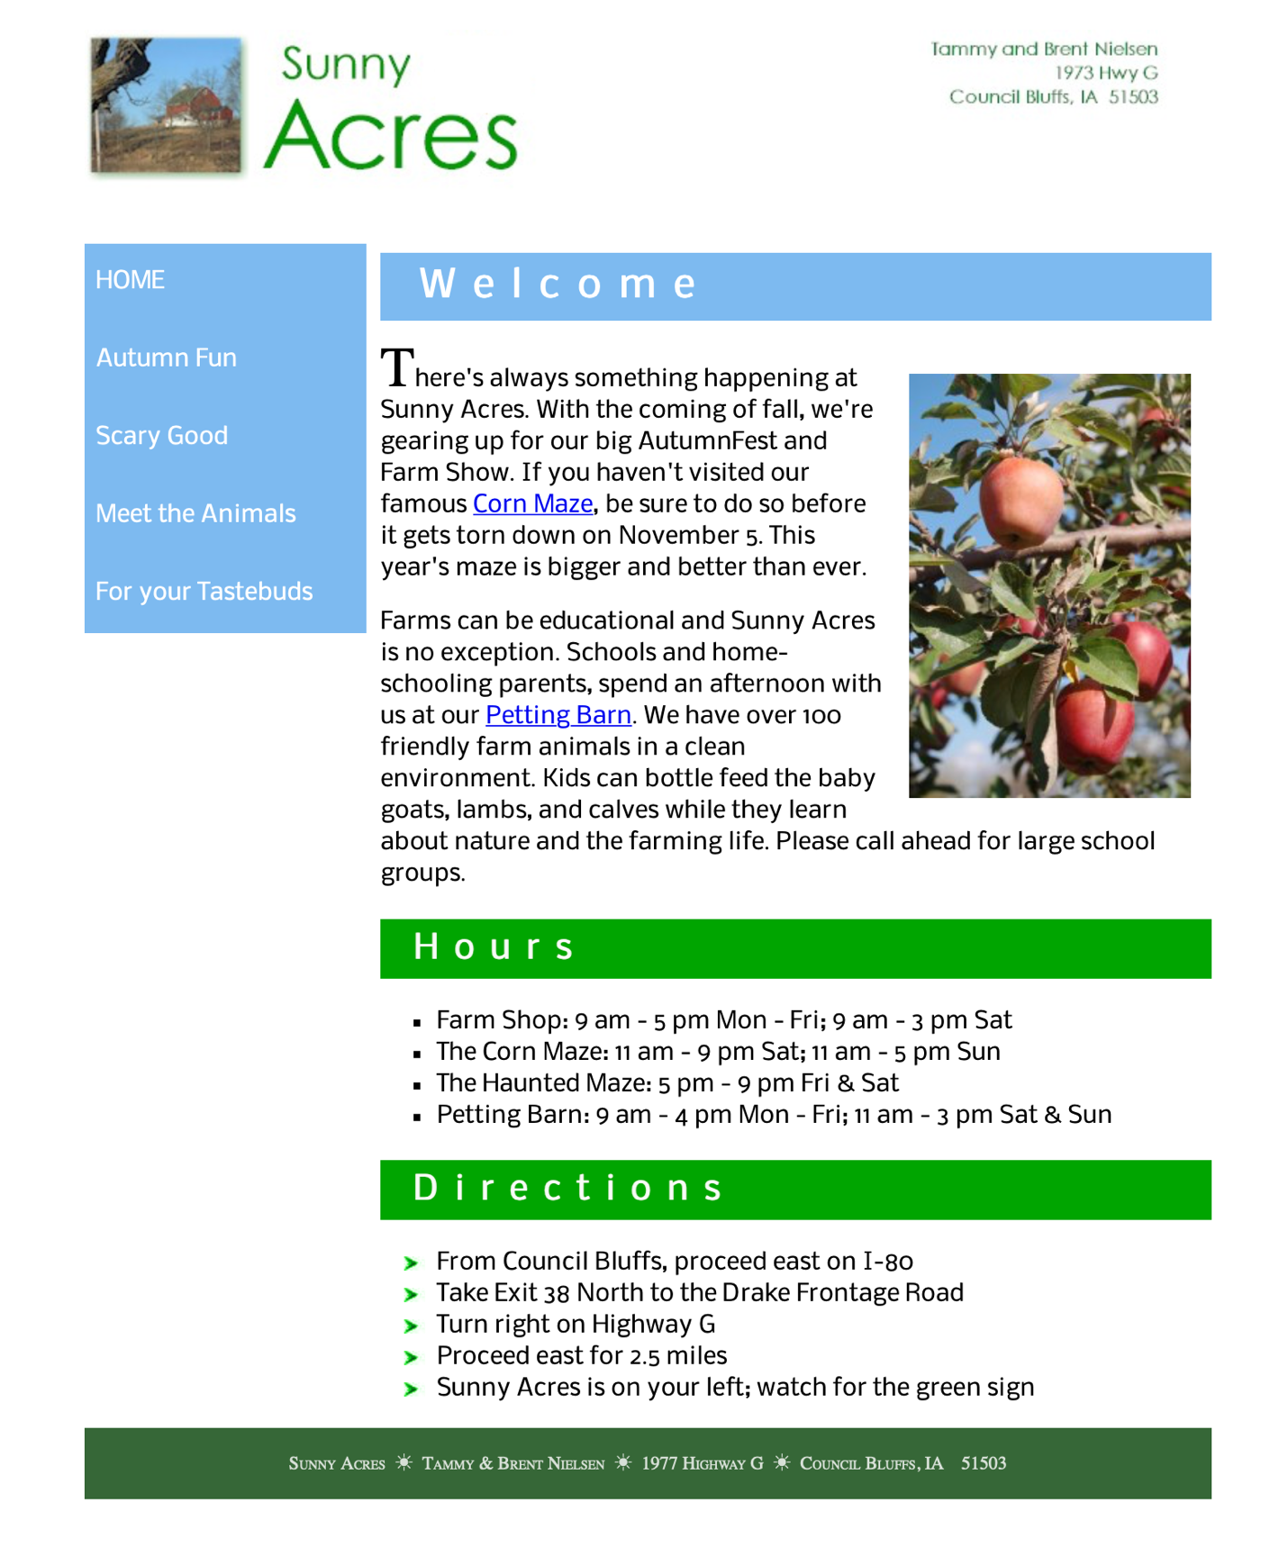

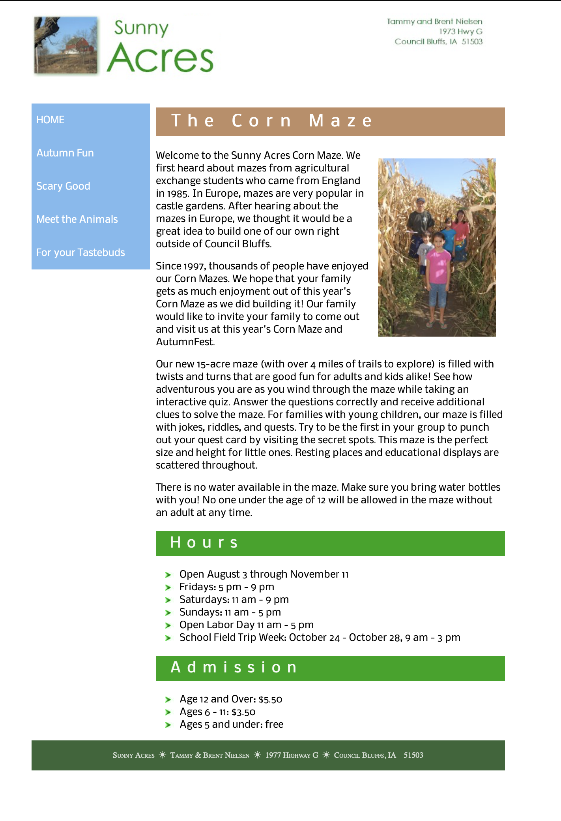

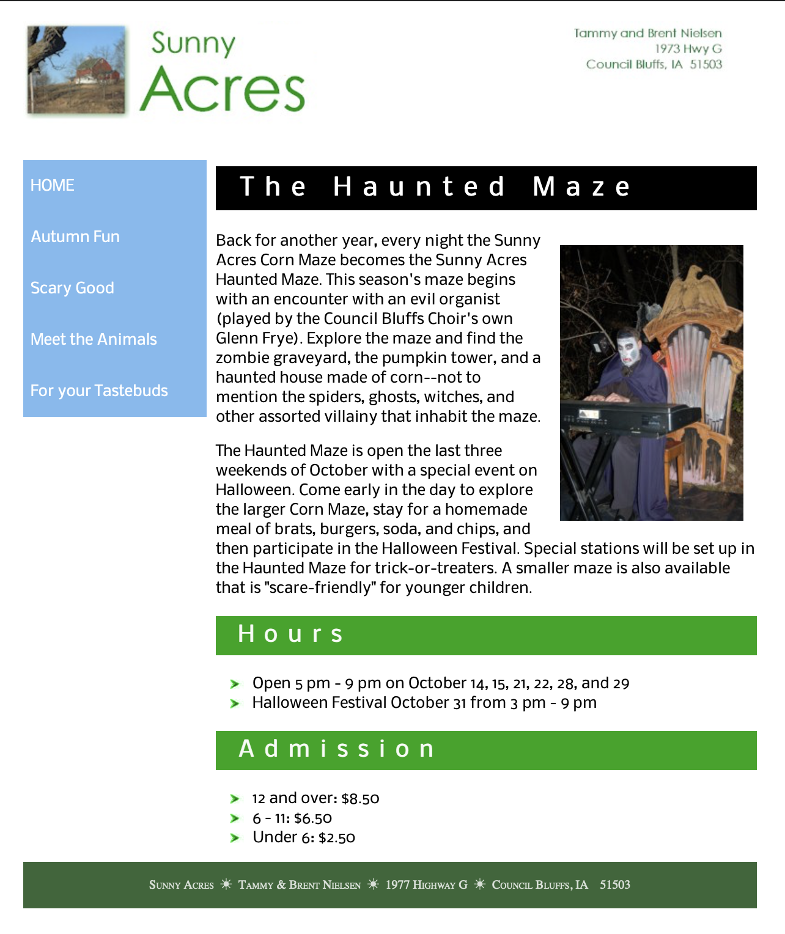

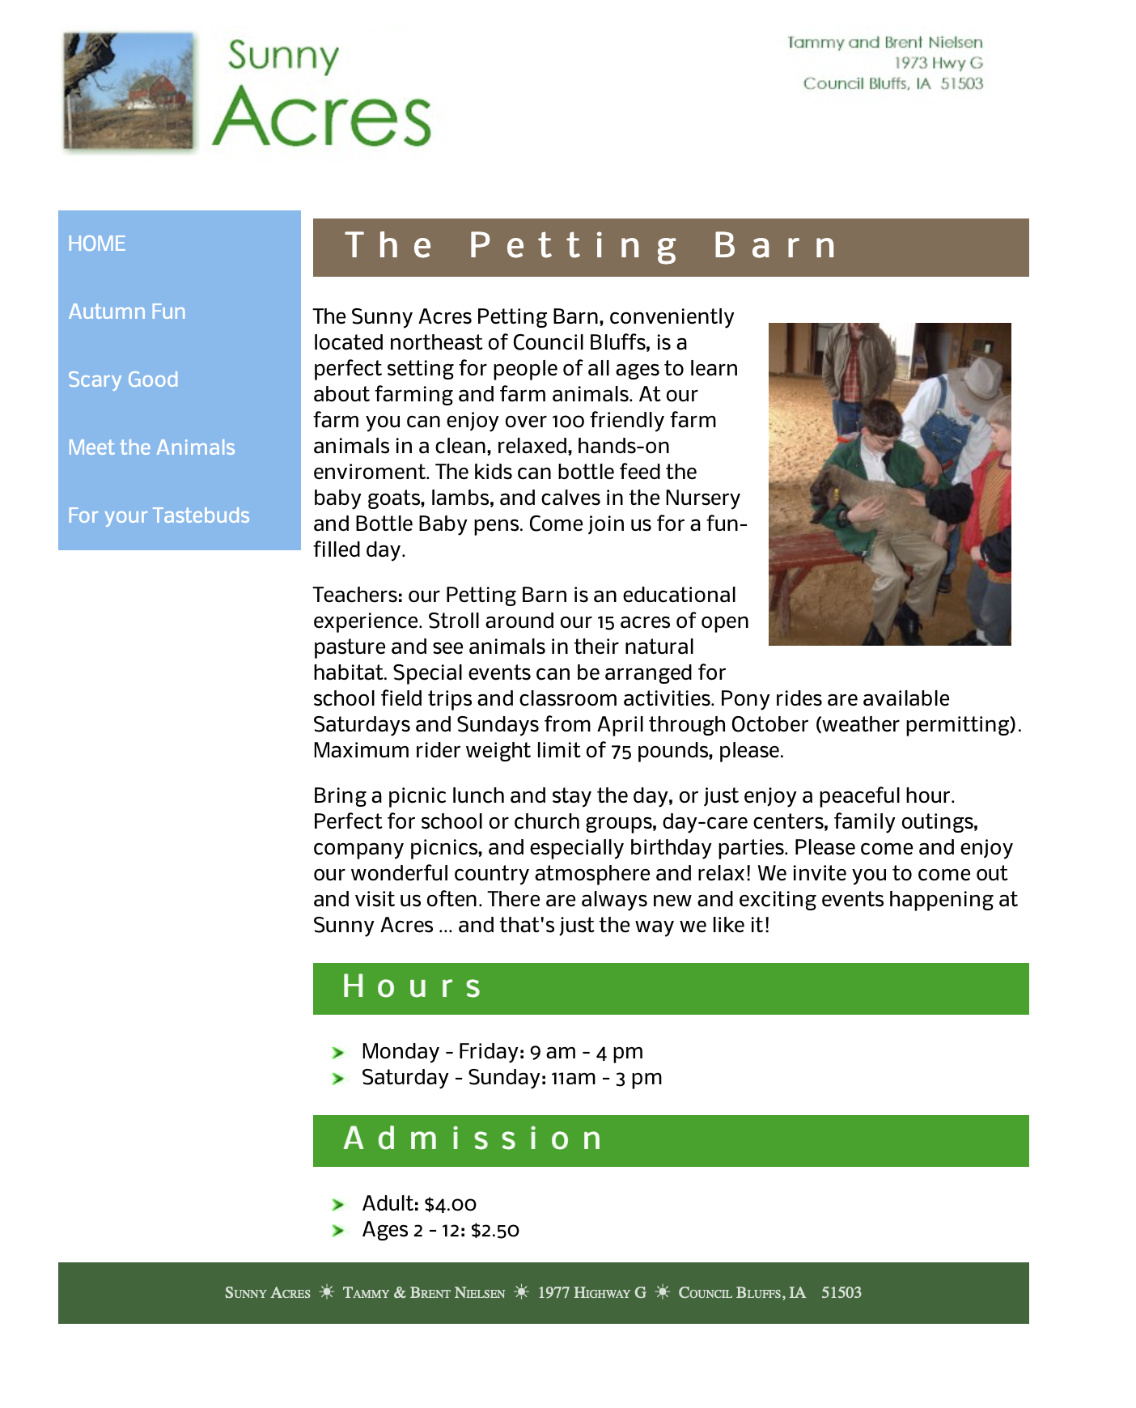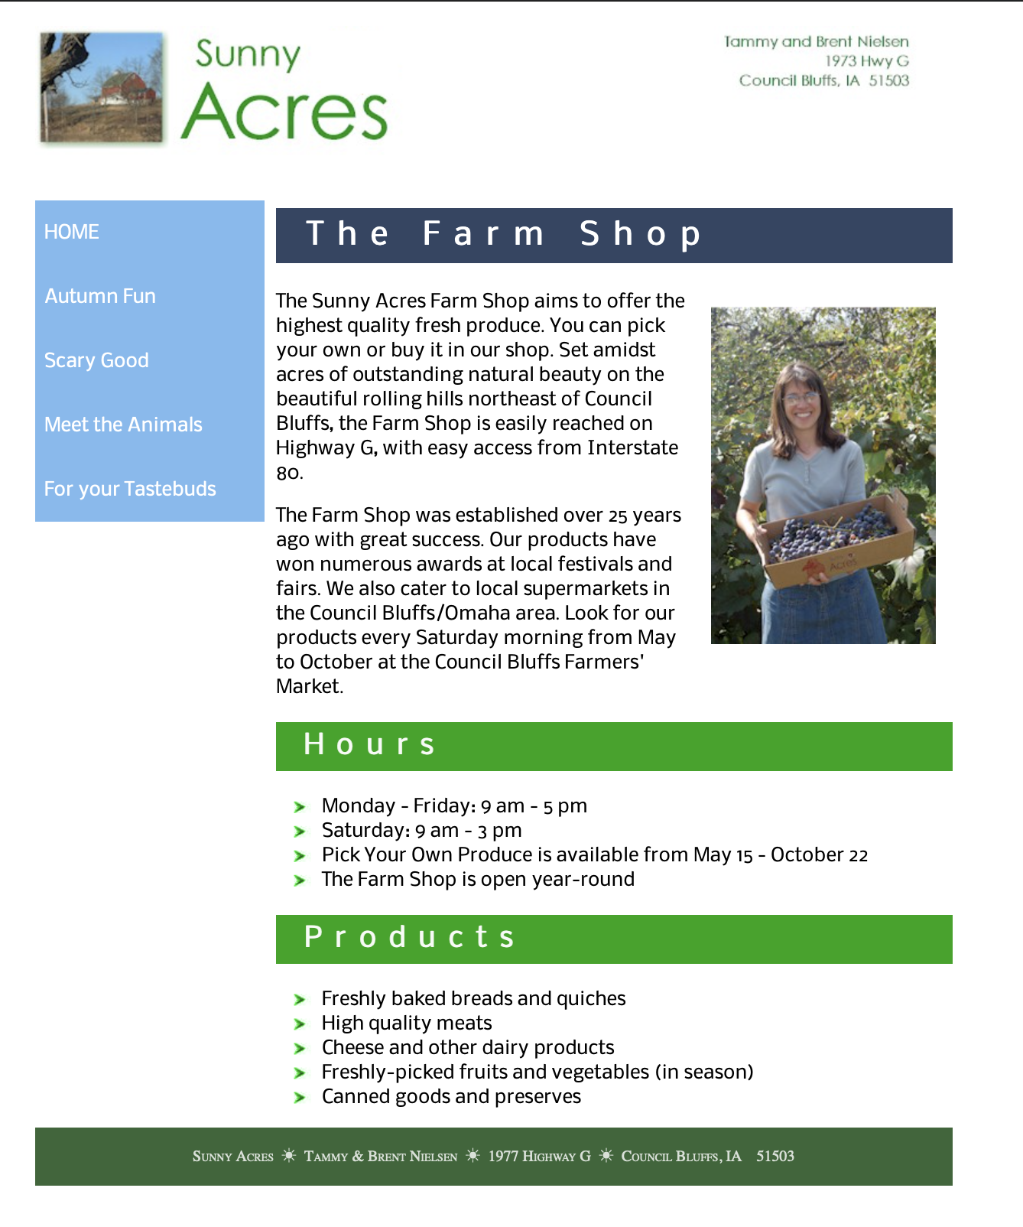

Pictures of the completed review web site

